

**Department of Engineering Technology**

**Foundation University Islamabad School of Science and Technology**

**Course: Database System Lab**

**Manual 5**

**Name: Muhammad faizan**

**Roll no:074**

# Topic: Setting up Database Environment and Performing Basic Database Operations via Command Line

|  |  |  |  |  |  |
| --- | --- | --- | --- | --- | --- |
| **Performance** | |  |  | **Lab Report** |  |
| **Description** | **Total**  **Marks** | **Marks Obtained** | **Description** | **Total**  **Marks** | **Marks Obtained** |
| Practical Setup and  Configuration | 5 |  | Command  Line Database  Operations | 5 |  |
| Report Writing | 5 |  |  |  |  |

Figure 1:new sql 3

Figure 2:create database 3

Figure 3:createtable 4

Figure 4:insert data 5

Figure 5:change varchar 5

Figure 6:change name 5

Figure 7:drop stack 6

Figure 8:adjust by price 6

Figure 9:by price in desc 7

Figure 10:Add field 7

Figure 11:limit to 20 8

Figure 12:modify into decimal 8

Figure 13change stack 8

Figure 14:show by price in asc 9

Figure 15by quantity in dsc 9

Figure 16:by product inasc 9

Figure 17:show only electrions product 10

Figure 18:describe product 10

**Step 1:**

* In this step start with mysql –u root –p.

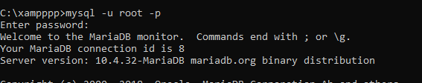

Figure 1:new sql

**Step 2:**

* In this step we create a new database named faizan_74;

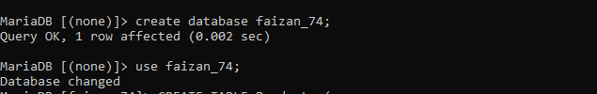

Figure 2:create database

**Step 3:**

* In this step we use faizan_74 database.
* Then we create a table named products.
* Then we set a fields of table.
* Then describe a table.

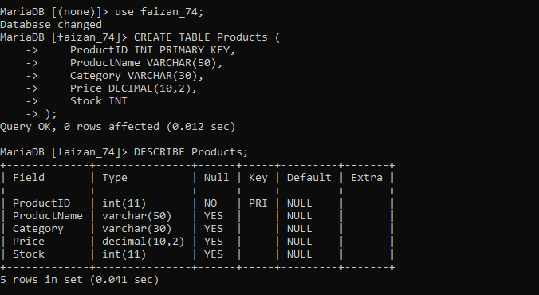

Figure 3:createtable

**Step 4:**

* In this step we insert a data into table.
* Then display a data into table.

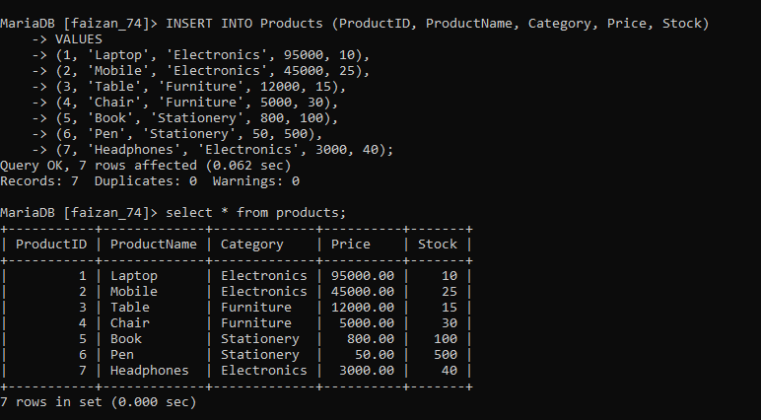

Figure 4:insert data

**Step 5:**

* In this step we modify a coulm using Alter.

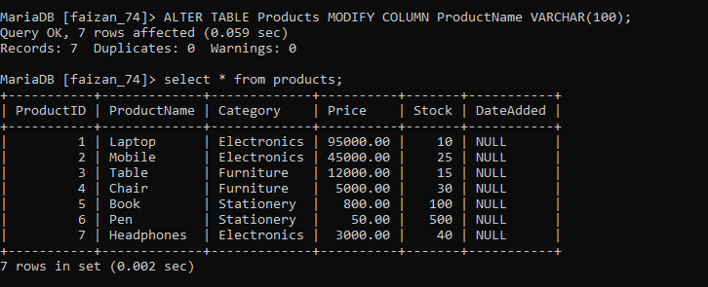

Figure 5:change varchar

**Step 6:**

* In this step we change a categoryname into productcategory.



Figure 6:change name

**Step 7:**

* In this step we drop a colum name stack.
* But later we add again stack into table.

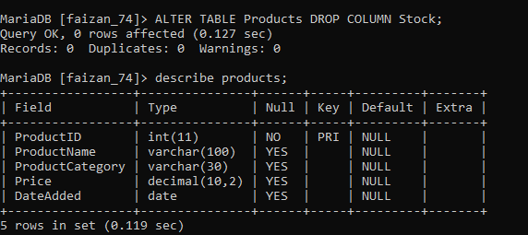

Figure 7:drop stack

**Step 8:**

* In this step we set a table by price.

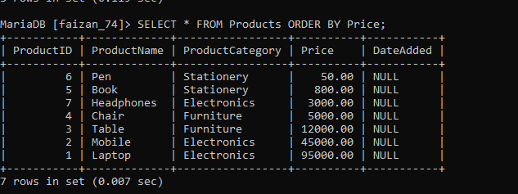

Figure 8:adjust by price

**Step 9:**

* In this step price set into descending order.

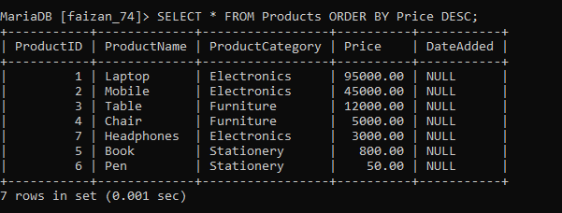

Figure 9:by price in desc

## ****Report:-****

1. In this lab we created a table named **products** to store product information.
2. We inserted different products like Laptop, Mobile, Table, and Chair.
3. We learned how to add, modify, and rename columns using the **alter table** command.
4. We also used **order by** to arrange data in ascending and descending order..

**Task:**

**Step 1:**

* In this step we add a field manufactuedate.

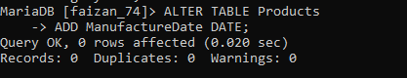

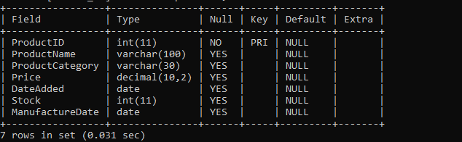

Figure 10:Add field

**Step 2:**

* In this step we modify a productcategory limit to 20.

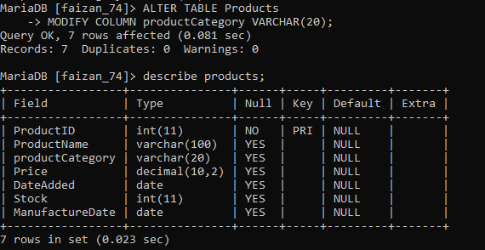

Figure 11:limit to 20

**Step 3:**

* in this step modify column price decimal.

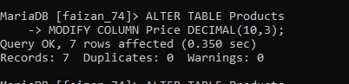

Figure 12:modify into decimal

**Step 4:**

* in this step change stock named into QuantityAvailable.

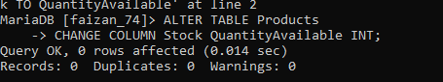

Figure 13change stack

**Step 5:**

* in this step adjust a table by price.

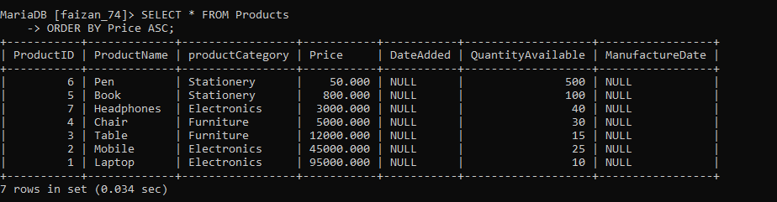

Figure 14:show by price in asc

**Step 6:**

* in this step adjust a table by Quantiy.

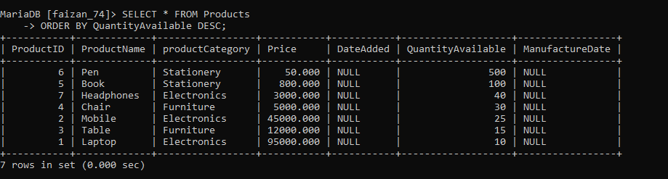

Figure 15by quantity in dsc

**Step 7:**

* in this step adjust a table by productcategory.

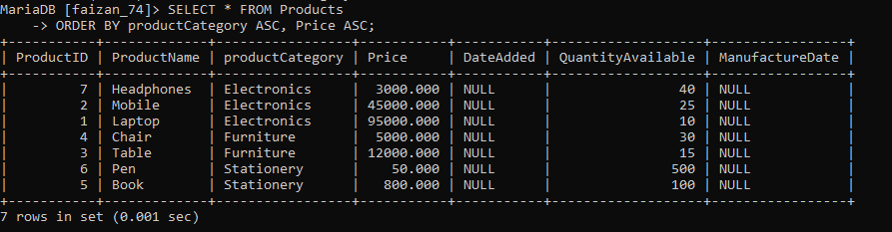

Figure 16:by product inasc

**Step 8:**

* in this step show a productcateroy in desc order.

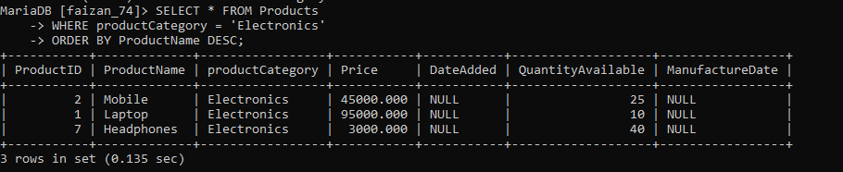

Figure 17:show only electrions product

**Step 9:**

* In this step describe a table.

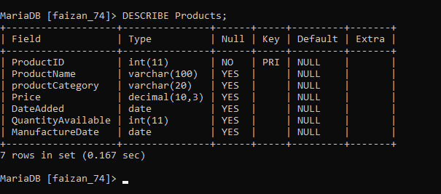

Figure 18:describe product

## ****Report:-****

1. In this task we changed and updated the structure of the **products** table.
2. We added a new column manufacture date and changed the size of Category and Price.
3. The stock column was renamed to QuantityAvailable.
4. We displayed product data in different sorted orders using **order by**.